**Roll No.: K036**

**Name: Arjun Mehta**

**Prog/Yr/Sem: B. Tech CSE Cybersecurity Year 2, Sem 3**

**Batch: K1**

**Date of Experiment: 26-07-2024**

**Date of Submission: 26-07-2024**

#include <iostream>

using namespace std;

#define MAX 100

int stack[MAX];

int top=-1;

int size()

{

return top+1;

}

void push(int x)

{

if(top>=MAX-1)

{

cout<<"Stack is full"<<endl;

}

else

{

top++;

stack[top]=x;

cout<<x<<" pushed to stack"<<endl;

}

}

void display()

{

if(top<0)

{

cout<<"Stack is empty"<<endl;

}

else

{

cout<<"Stack elements="<<endl;

for(int i=top;i>=0;i--)

{

cout<<stack[i]<<endl;

}

}

}

bool isEmpty()

{

if(top==-1)

{

return true;

}

else

{

return false;

}

}

void pop()

{

if(isEmpty())

{

cout<<"Stack is empty"<<endl;

}

else

{

cout<<stack[top]<<" popped from stack"<<endl;

top--;

}

}

int peek()

{

if(isEmpty())

{

cout<<"Stack is empty"<<endl;

return -1;

}

else

{

return stack[top];

}

}

int main()

{

int choice,x;

while(1)

{

cout<<"\nChoose from the Menu driven program below:-";

cout<<"\n1. Push\n2. Pop\n3. Display\n4. Peek\n5. Size\n6. Is Empty\n7. Exit\n";

cout<<"Enter your choice= ";

cin>>choice;

switch(choice)

{

case 1:

cout<<"Enter element to push= ";

cin>>x;

push(x);

break;

case 2:

pop();

break;

case 3:

display();

break;

case 4:

x=peek();

if(x!=-1)

{

cout<<"Top element is= "<<x<<endl;

}

break;

case 5:

cout<<"Stack size is= "<<size()<<endl;

break;

case 6:

cout<<"Is stack empty? "<<(isEmpty()?"Yes":"No")<<endl;

break;

case 7:

cout<<"Exited"<<endl;

return 0;

default:

cout<<"Invalid choice"<<endl;

}

}

return 0;

}

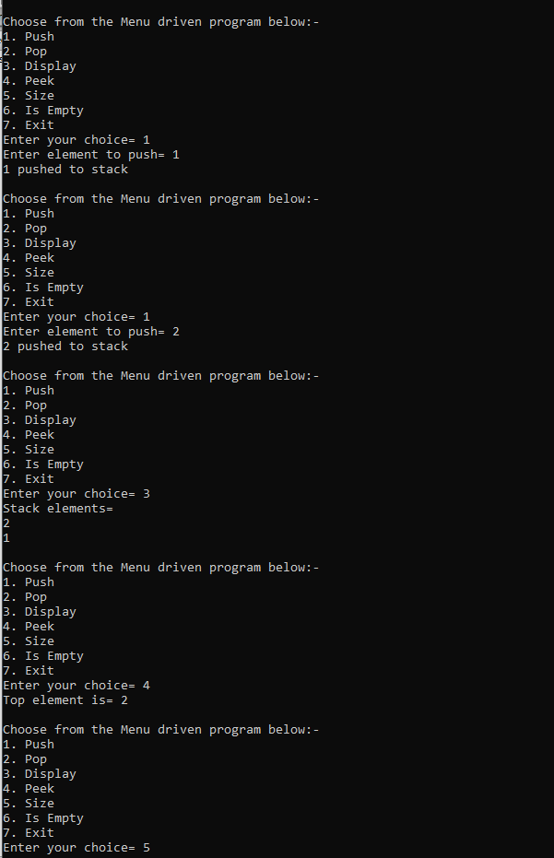

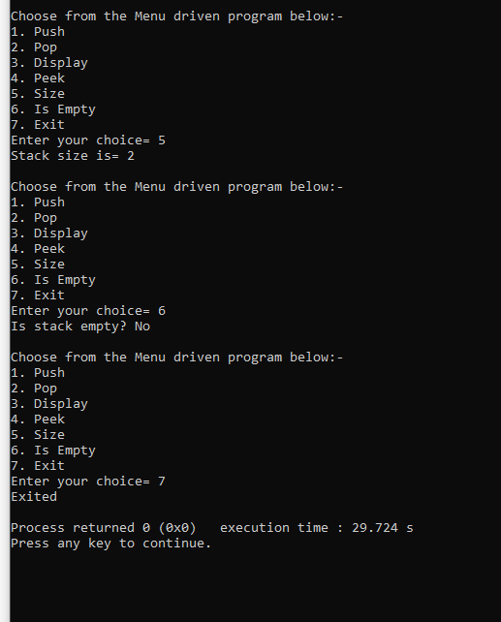

// Question 1: Write a program to reverse a given list / array using Stack data structure.

#include <iostream>

#include <stack>

using namespace std;

void reversearray(int arr[],int size)

{

stack<int> s;

for(int i=0;i<size;i++)

{

s.push(arr[i]);

}

for(int i=0;i<size;i++)

{

arr[i]=s.top();

s.pop();

}

}

void printarray(int arr[],int size)

{

for(int i=0;i<size;i++)

cout<<arr[i]<<" ";

cout<<endl;

}

int main()

{

int size;

cout<<"Enter the size of the array= ";

cin>>size;

int* arr=new int[size];

cout<<"Enter the elements of the array= ";

for(int i=0;i<size;i++)

cin>>arr[i];

cout<<"Original array= ";

printarray(arr,size);

reversearray(arr,size);

cout<<"Reversed array= ";

printarray(arr,size);

delete[] arr;

return 0;

}

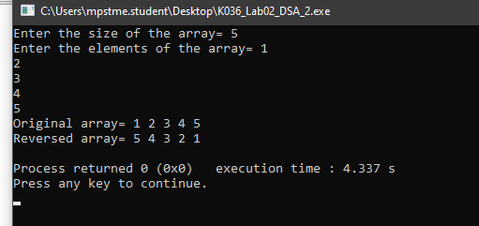

// Question 2. Write a program to convert decimal to binary number using Stack data structure

#include <iostream>

#include <stack>

using namespace std;

void d2b(int n)

{

stack<int>s;

while(n>0)

{

s.push(n%2);

n/=2;

}

if(s.empty())

cout<<0;

else

{

while(!s.empty())

{

cout<<s.top();

s.pop();

}

}

cout<<endl;

}

int main()

{

int decimal;

cout<<"Enter a decimal number= ";

cin>>decimal;

cout<<"Binary representation= ";

d2b(decimal);

return 0;

}

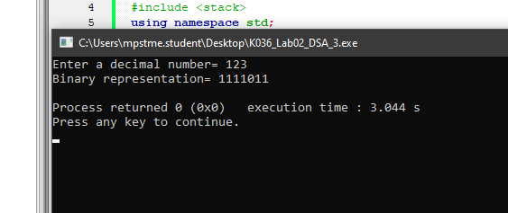

// Question 3. Write a program to check if given expression has balanced parentheses or not.

#include <iostream>

#include <stack>

using namespace std;

bool isBalanced(const string& expr)

{

stack<char> s;

for(size_t i=0;i<expr.length();i++)

{

char c = expr[i];

if(c=='('||c=='{'||c=='[')

s.push(c);

else if(c==')')

{

if(s.empty()||s.top()!='(')

return false;

s.pop();

}

else if(c=='}')

{

if(s.empty()||s.top()!='{')

return false;

s.pop();

}

else if(c==']')

{

if(s.empty()||s.top()!='[')

return false;

s.pop();

}

}

return s.empty();

}

int main()

{

string expr;

cout<<"Enter an expression= ";

cin>>expr;

if(isBalanced(expr))

cout<<"Expression is balanced"<<endl;

else

cout<<"Expression is not balanced"<<endl;

return 0;

}

